No child should suffer harm, either at home or at school. Everyone who works in our school has a responsibility to make sure that all our young people are safe.  This leaflet has been given to you to make sure you understand what is expected of you. Please ask the school's DSL if you are unclear about anything in it, and keep the leaflet in a safe place, so that you can read it again if you need to.  If you are worried about the safety of any young person in our school, you must report this to the DSLs  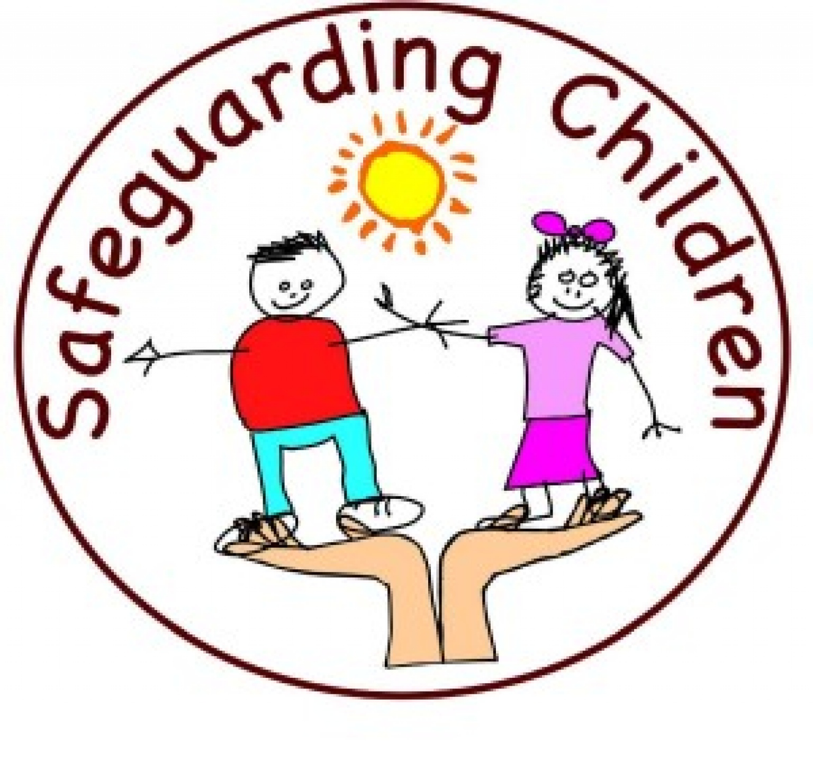 |  | Contacts  HEAD TEACHER:  Jayne Renshaw  DESIGNATED SAFEGUARDING LEAD FOR SAFEGUARDING CHILDREN (DSL):  Jayne Renshaw, Head Teacher  DEPUTY DSL:  Naomi Townsend Deputy Head  Jessica Stretton-Clarke SENCO  GOVERNOR WITH SAFEGUARDING RESPONSIBILITY:  Louise Knott  CHAIR OF GOVERNORS:  Louise Knott  Healdswood Infant and Nursery School  Head Teacher: Jayne Renshaw  Tel: 01623 462449  office@healdswood.notts.sch.uk  Barker Avenue  Skegby, Sutton-in-Ashfield  Nottingham, NG17 3FQ |  |   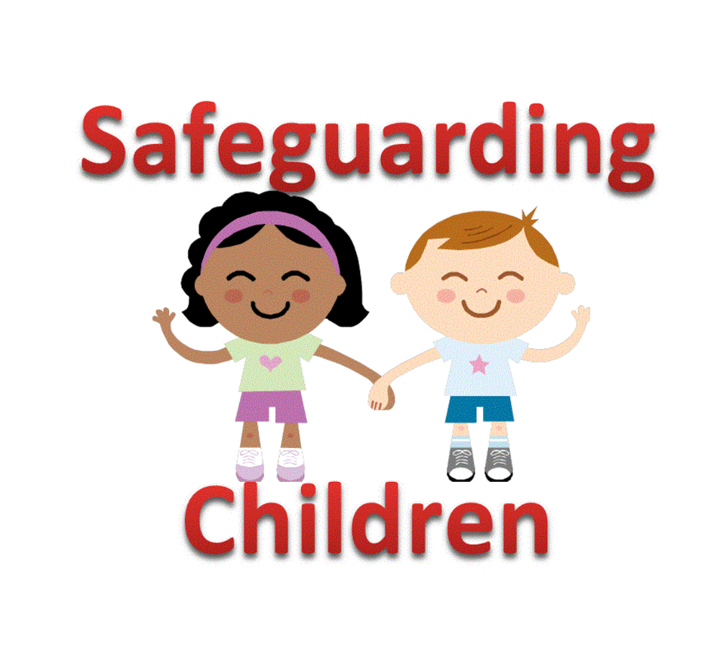  Banks Road Infant and Nursery School  Banks Road Infant and Nursery School  Banks Road Infant and Nursery School  Safeguarding Advice  for  Volunteers  &  Regular Visitors  Healdswood Infant and Nursery School  

Child Protection Advice  Thank you for your interest in becoming a volunteer or regular visitor. As a school we are committed to safeguarding and meeting the needs of children and we hope this leaflet will provide some useful advice and information when working with children at Healdswood Infant & Nursery School.  What are my responsibilities?  All those who come into contact with children through their every day work, whether paid or voluntary, have a duty to safeguard and promote the welfare of children.  DBS checks  Healdswood’s Recruiting and Selection Procedures specify that all adults who work in 'regulated activity' and work in a 'specified place' such as a school and this work is regular - i.e. once a week or more or 4 or more days in a 30 day period or overnight - will require an enhanced DBS Disclosure. This is to help ensure that unsuitable people are prevented from working with children. If your work with children means that you are supervised at all times, this may not be required.  Rebecca Drayton, Office Manager, will set up your DBS on-line application and advise which documentation is necessary for you to present for the ID checks to be completed. You can apply to join the 'update service' at the same time to ensure that your certificate is portable. You must show your certificate to the Office Manager as soon as you receive it. The Head may ask you to give signed consent so that he/she can use the update service.  It is a requirement, also, that you inform the Head teacher immediately if you become subject to any criminal investigation, caution or conviction. This helps to protect you as well as the young people in your care. |  | Healdswood Infant and Nursery School has a Safeguarding Policy and a copy is available on the school website:  www.healdswood.notts.sch.uk  What should I do if I am worried about a child?  If whilst working with a child you become concerned about:  Comments made by a child  Marks or bruising on a child  Changes in the child’s behaviour or demeanour  Please report these concerns to the class teacher, who if they feel it is appropriate will pass the information on to the school’s Senior Designated Person for Safeguarding.  What should I do if a child discloses that s/he is being harmed?  Although the likelihood of this is small it is important to know what to do in such an eventuality as children rarely lie about such matters  - Listen to what is being said without displaying shock or disbelief; accept what is being said  - Allow the child to talk freely  - Reassure the child, but do not make promises that might not be possible to keep  - Do not promise confidentiality but explain to the child that you may have to tell their teacher or Head teacher in order that they can provide appropriate help  - Do not interrogate the child or ask leading questions  - Reassure the pupil that it is not their fault  - Stress that it was the right thing to tell  - Do not ask the child to write a statement  - Do not criticise the alleged perpetrator  Immediately record details of the disclosure, including wherever possible the exact words or phrases used by the child and should be handed to the Designated Safeguarding Person to enable the matter to be dealt with in the most appropriate way. Please ensure you have signed and dated the record. |  | What should I do if the alleged abuser is a member of the school staff?  You should report such allegations to the Head teacher.  What should I do if the alleged abuser is the Head teacher?  You should report such allegations to the Chair of Governors or the Deputy Designated Safeguarding Lead.  What should I do if I witness worrying behaviour by another adult in school?  You should always report this to the Head teacher.  How do I ensure that my behaviour is always appropriate?  Appropriate relationships with children should be based on mutual trust and respect.  As a volunteer or regular visitor you may well be working closely with children sometimes on a one to one basis.  Children, especially when they are young, are often spontaneously affectionate and tactile and it is important not to alienate them through lack of response or by appearing to reject this. You should, however, be careful about touching pupils.  If you are working with a pupil on his/her own always ensure that the door is left open or that you can be visible to others.  Do not photograph pupils, unless requested to by the class teacher, exchange e-mails or text messages, or give out your own personal details. Any unprofessional contact with pupils (e.g. through a social networking site) may leave you vulnerable to an allegation of abuse being made against you.  Please help us to safeguard the children in our care by following these guidelines.

