

Healdswood Infant and Nursery School

SEND Information Report
2026 – 2027

Our School | Our School Vision  At Healdswood Infant and Nursery School the well-being and development of each child underpins all that we do. Our aim is to develop children into confident and resilient learners, for them to develop a love of learning and to encourage them to explore opportunities to step outside of their comfort zone whilst not neglecting the need to develop wider life skills that they can use to underpin their future development.  September 2026 Information  Healdswood Infant and Nursery School currently has 124 children on role (September 2026)  There are currently 27 children on the SEND register with a range of needs from universal to specialist. (22% of pupils are on the SEND Register)  Broad Area of Need and the SEND Register:  - Communication and Interaction - 25 children (93%)  - Social, Emotional and Mental Health (SEMH) – 2 children (7%)  20 children on the SEND Register receive Speech and Language support (74%).  7 children have an EHCP (26%).  11 children (40%) are in receipt of additional funding.  5 children (19%) receive Higher Level Need (HLN) funding.  6 children receive High Additional Family Needs (AFN) Funding. 2 are funded at Low AFN, 1 is funded at Medium AFN and 3 are funded at High AFN.
  Meet our SENDCo |   The SENCo is Miss Stretton-Clarke  If you would like to contact Miss Stretton-Clarke, please call school on 01623 462449 or email office@healdswood.notts.sch.uk or senco@healdswood.notts.sch.uk
  Special Educational Needs | At Healdswood Infant and Nursery School, we support children with a variety of differing special educational needs and we pride ourselves on being a highly inclusive school with an ethos which encourages and celebrates diversity and difference.  SEND is categorised into the following areas in the SEN code of practice 2014:
   | Cognition and Learning
   | Communication and Interaction
   | Social, Emotional and Mental Health
   | Sensory and Physical
  Identifying and Assessing Need | At Healdswood Infant and Nursery School we work closely as a team and if staff have a concern about a child, they fill in an Initial Concerns form and discuss concerns with parents. A child will then be placed on the monitoring register and we begin to follow the Graduated Response approach of ‘Assess, Plan, Do and Review’.  After a period of 6 – 8 weeks we will decide if a child needs to be placed on the SEND register and invite you in for a meeting, where we will share the targets your child is working on and the support they are receiving.  Some children will be monitored using BSquared Assessment. This allows the children who are working at below key stage standards to have small step targets set in lessons to allow them to achieve and begin to work independently.  Some children may require more support than is ordinarily available and we may ask outside agencies to support us in ensuring that we are offering the best support we can.  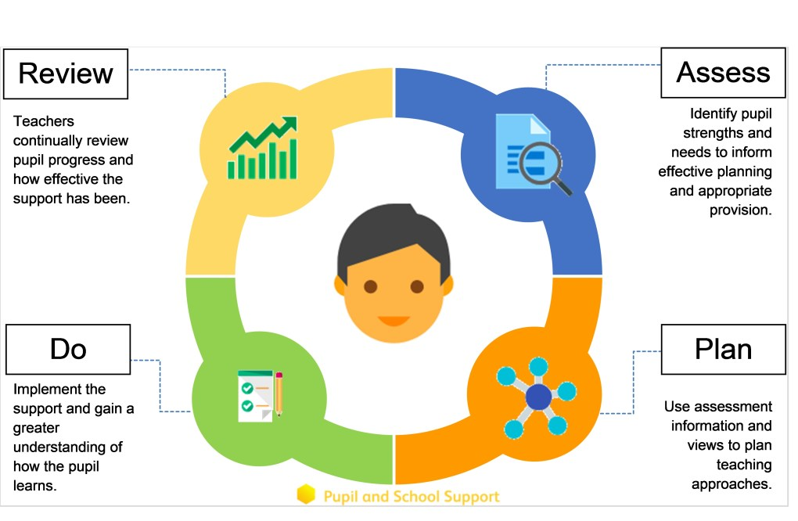
  Our approach to teaching children with SEND | We are an inclusive school. Wherever possible children are taught alongside their peers in flexible teaching groups.  Teachers adapt their high-quality teaching to cater for their pupils’ needs and plan individual timetables where necessary. When appropriate, staff are deployed to give children additional interventions in small groups outside the classroom, or to provide one-to-one support.  We use the EEF guidance ‘Five-a-day’ and embed the key principles into all our lessons.  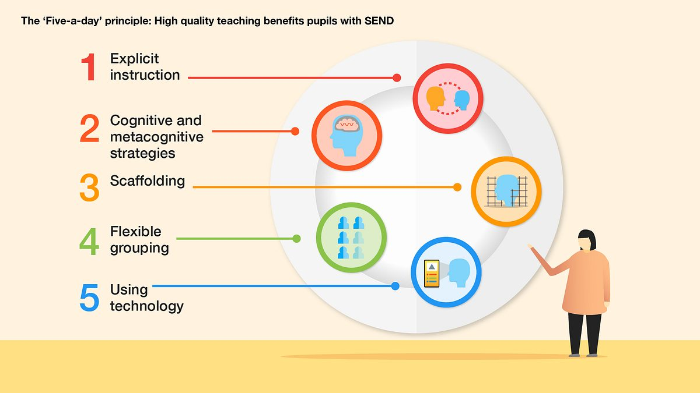
  Curriculum adaptations | We use a range of strategies across our lessons to ensure we offer an inclusive approach to learning and allow all children to access the classroom environment.  We also seek advice and equipment from outside agencies as and when the need arises.
   | 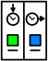 | 
  Visual timetables | Task boards | Peer mentoring
   |  | 
  Assistive technology | Talk partners | Peer marking
   |  | 
  Self-assessment | Word banks | Positive behaviour
   |  | 
  Ear defenders | Timers | Explicit instruction
  Parent Consultations | At Healdswood Infant and Nursery School, we work closely with parents and carers and recognise that they have much to contribute to our support for children with SEND.  We hold SEN Coffee Mornings every term. We hold three coffee mornings a year where parents can meet up and support each other in a safe environment. During these sessions we gather parent feedback on SEN provision at Healdswood Infant and Nursery School, direct to training courses and support groups and offer opportunities to meet up with outside agencies.  Miss Stretton-Clarke is available at parents’ evenings to discuss any concerns.  For children who have an Education, Health and Care Plan, Individual Education Plan (IEP) or require specialist support (over and above what is ordinarily available) we will invite you in for 3 further meetings a year in the Autumn, Spring and Summer term. These meeting are used to celebrate your child’s learning, looking at the progress they have made against the targets set, create new targets and discuss next steps. A copy of this will always be sent home after the meetings.  During the year a parental questionnaire is sent out to gain views on the school and the SEND provision.
Child Consultations | Pupil’s views are very important; they have a right to be involved in decisions about their education and they are made aware of the support that surrounds them in school.  Children are fully involved and their views feed directly into all policies, procedures and daily teaching of children with SEND.  Pupils are given regular opportunities to:
   |  | 
  Self-assess how they are doing | Attend meetings and help decide the support needed. | Feedback and Review progress/interventions.
  Evaluating Provision | Review progress in SLT meetings and discussing next steps.  Discuss and share ideas in staff meetings to ensure up to date research and policy is in place.  Reviewing children’ individual progress towards their goals at regular intervals, as a minimum every term.  Establishing children’s baseline before receiving interventions and reviewing the impact of interventions at regular intervals.  Asking our children if they feel the adjustment or intervention is helpful and makes a difference.  Monitoring by the SENDCO.  Regularly using a tracking tool to update targets and measure progress.  Holding termly reviews for children who are on Education Health and Care Plans, Individual Education Plans (IEP) and those requiring specialist support.  Holding annual reviews for children with Education Health Care Plans.
  Staff Training | At Healdswood Infant and Nursery School, we believe in professional development and aim to ensure all our staff have the understanding they need to enable them to support your child.  When a new member of staff joins the school, we ensure they understand the systems within school and they are given information about the children they are working with.  The senior leadership team within school are constantly moderating needs within the school and, where an area of concern is highlighted, whole school training could be organised to ensure all staff understand specific learning difficulties and appropriate teaching or support strategies that could be utilised.  If your child needs specialist support from an outside agency, such as the Speech and Language Service (SALT), Educational Psychologist (EP), Occupational Therapist (OT) or school nurse, we will always discuss this with you first.  Some of our staff have completed training in the following areas. When staff go on a course, they have an opportunity to give feedback to the rest of the staff during staff meeting sessions.
   |  |  | 
  Interoception | Lego Therapy | Fun Fit | Bucket time
   |  |  | 
  Understanding Autism | Makaton – Level | Intensive Interaction | Self-regulation
   |  |  | 
  De escalation | Relational Schools  Attachment Aware and Trauma Informed | Sensory needs | Speech and Language
   |  |  | 
  Drawing and Talking | Exploring Emotions Through Art | Exploring Emotions Through Nursery Rhymes | Thrive
  Transition Support | End of Year transition  When children move up a year, we provide transition sheets which include photos of the teacher, TA and classroom environment.  We hold 2 transition sessions during the summer term allowing the children to go up to their new classroom and meet their teacher. Some children may require extra transition visits to their new classroom to help reduce their anxiety and ensure that the transition is successful and positive.  Class teachers and TAs meet with each other during the summer term to discuss the needs of the children and share Individual Learning Plans.  We hold a number of sessions for our nursery new starters to come and see the environment prior to starting with us.  Mid-Year new starters  When we are aware that pupils joining us from other settings have identified special educational needs, we arrange a meeting with the family to enable us to gain a greater understanding on the support we need to put in place. We liaise closely with children’s previously schools to collect information that helps us implement the correct support.
  Outside Agencies | We work with the following agencies to provide support for children with SEND:  SEND Inclusion Service (SIS)  Statutory SEND Service (SSS)  Physical disability specialist services (PDSS)  Speech and Language Therapy  Educational Psychologists  SEMH Team  Occupational Therapy  Physiotherapy  The SENDCo can raise children at termly ‘Springboard’ meetings with other SENDCos in the family of schools, the family SENDCo and other outside agencies for support, advice and involvement. We will ask your permission before we arrange for any outside agencies to come in and work with your child. Once the feedback has been received we will call you in for a meeting to share the advice.
  Clubs and Trips | All our extra-curricular activities and school visits are available to all our children, including our after-school clubs. All children are encouraged to go on our trips.  All children are encouraged to take part in sports day, school competitions, school assemblies and performances, workshops, etc. No child is ever excluded from taking part in these activities because of their SEN or disability.  Please read the school’s accessibility plan for further information about the steps we have taken to prevent disabled children from being treated less favorably than other children and the arrangements we have made to help children with SEND access our school.
  Nottinghamshire  Local Offer | The Nottinghamshire Local Authority Local Offer can be found at  https://www.nottshelpyourself.org.uk/kb5/nottinghamshire/directory/site.page?id=yIRabI1bcHo

